CORE LEVEL 1 TRAINING POSTS – Job Description for 2026 Recruitment
 | Job Description | Trust | Site | Clinical Supervisor | Specialty
1 |  | Nottinghamshire (Mansfield) | Sherwood Oaks/Newark | Dr C Innes | General Adult  EMD/S4K5W/052/LT/004
2 |  | Nottinghamshire  (Mansfield) | Blossomwood | Dr A Rajamani | Old Age  EMD/RHABW/056/CT/002
3 | 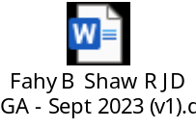 | Nottingham | Highbury | Dr E Agada/Dr B Fahy | General Adult  EMD/RHANM/052/CT/007
4 |  | Nottingham | Highbury | Dr S Chatterjee | Old Age  EMD/RHANM/056/CT/001
5 | 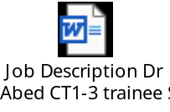 | Nottinghamshire  (Mansfield) | Sherwood Oaks | Dr H Abed | General Adult  EMD/S4K5W/052/LT/003
6 |  | Nottinghamshire  (Mansfield) | Blossomwood | Dr I Katuwawela | Old Age  EMD/RHABW/056/CT/001
7 | 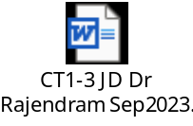 | Nottinghamshire  (Mansfield)  (Expansion post Aug 24) | Sherwood Oaks | Dr M Rajendram | General Adult/Crisis  EMD/S4K5W/052/LT/006
8 |  | Nottinghamshire  (Mansfield) | Blossomwood | Dr L Davis | Old Age  EMD/RHABW/056/LT/001
9 |  | Nottinghamshire  (Mansfield) | Blossomwood | Dr A Rajamani  (vice C Gordon) | Old Age  EMD/RHABW/056/LT/002
10 |  | Nottinghamshire  (Mansfield) | Sherwood Oaks | Dr R Habib | General Adult  EMD/S4K5W/052/LT/005
12 |  | Nottinghamshire  (Mansfield) | Sherwood Oaks | Dr P Pathy | General Adult  EMD/S4K5W/052/LT/002

13 |  | Nottingham | Highbury Cherry Ward | Dr K Ward | Old Age  EMD/RHANM/056/LT/001
14 |  | Nottinghamshire (Mansfield) | Blossomwood Dove Ward | Dr O Manzar | Old Age  EMD/RHANM/052/CT/007

