1. |  | Nottingham | Highbury | Dr B Lomas | General Adult -CRHT  EMD/RHANM/052/CT/013
2. |  | Nottingham | Pebble Bridge  Hopewood  Foster Drive  Mansfield Road  Nottingham  NG5 3FL | Dr P Chand | CAMHS (South) Community  EMD/RHAFL/053/LT/001
3. |  | Nottinghamshire/  Newark | Newark Northgate and Langold | Dr D Joseph | Child Psychiatry  EMD/RHAD4/053/LT/001
4. |  | Nottingham | QMC/Highbury | Prof C Hollis/  Dr M Fatek | Neurodevelopmental/ID  EMD/RHARA/053/CT/001
5. | 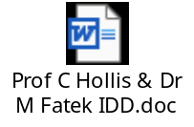 | Nottinghamshire | Highbury | Dr M Fatek | Intellectual Disabilities  EMD/RHAW9/051/LT/001
6. |  | Nottingham | Highbury | Dr N Shaikh  (nee Dr K Jeenkeri | Intellectual Disabilities  EMD/RHANM/051/CT/003
7. |  | Nottingham | Hopewood | Dr A Au-Yong/Dr C Kelly | Perinatal  EMD/RHAFL/052/CT/001
8. |  | Nottingham | Rampton | Dr I Yanson | Forensic  EMD/RHA04/054/CT/003
9. |  | Nottingham | Rampton Hospital | Dr T Gedeon | Forensics  EMD/RHA04/054/LT/001
10. |  | Nottingham | The Level 56 Millers Court, NG7 3DP | Dr E Holliday | Drug & Alcohol  EMD/RHANM/052/CT/003
11. |  | Nottingham | The Level 56 Millers Court, NG7 3DP | Dr J Barker | Drug & Alcohol  EMD/RHANM/052/CT/008
12. |  | Nottingham | Highbury | Dr E O’Regan (Lead CS)  Dr K Thangavelu | PICU  EMD/RHANM/052/CT/009
13. |  | Nottingham | QMC | Dr G Worwood | Liaison  EMD/RHARA/052/CT/007
14. | 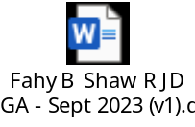 | Nottingham | Rowan 2/Beeston Community | Dr R Shaw/Dr B Fahy | General Adult  EMD/RHANM/052/CT/019
15. | 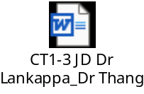 | Nottingham | Highbury | Dr S Lankappa / Dr K Thangavelu | General Adult  Redwood 1  LMHT City  EMD/RHANM/052/LT/003
16. |  | Mansfield | Sherwood Oaks | Dr H Abed | General Adult  EMD/S4K5W/052/LT/003
17. |  | Nottinghamshire  Mansfield | Blossomwood | Dr I Katuwawela | Old Age  EMD/RHABW/056/CT/001
18 |  | Nottingham | Highbury  Inpatient / Community | Dr J Gibson (Inpatient)  Dr V Gopal (Community) | General Adult  EMD/RHANM/052/LT/004
19 |  | Nottinghamshire  Mansfield | Sherwood Oaks  Inpatient / Community | Dr R Habib (Inpatient)  Dr H Bhogal (Community) | General Adult  EMD/S4K5W/052/LT/007
20 | 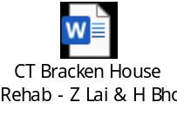 | Nottinghamshire  Mansfield | Bracken House  Rehab | Dr Z Lai | General Adult  EMD/RHABW/052/CT/013

