

Enhance Enable

Self-directed online modules via PGVLE. Six modules available to all Foundation doctors

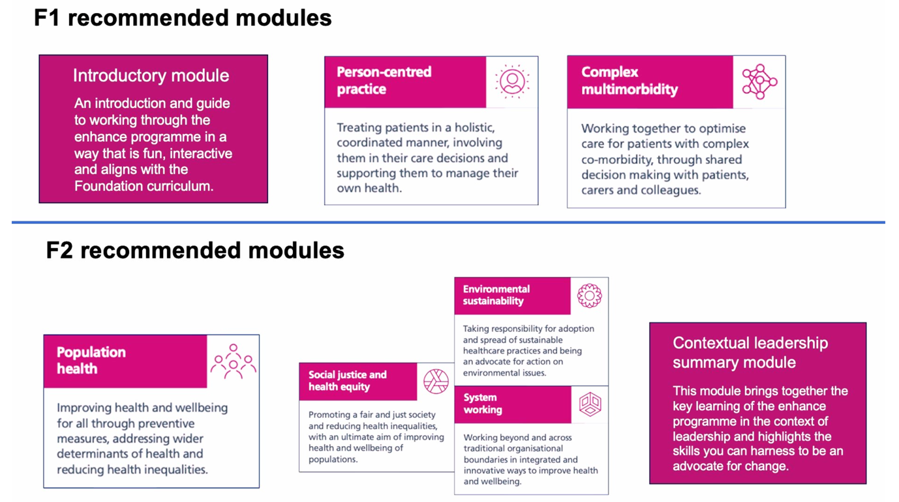

Advantages
- A way to gather the necessary portfolio evidence for the foundation curriculum.
- Completing all six modules equates to 5 hours of core teaching (e.g., 3 modules equal 2.5 hours).
- Completing the modules can also count toward non-core teaching hours if the core hours are already fulfilled.
- You can claim study leave for the time spent completing the modules: finishing 6 modules grants 3 days off as study leave, while completing 3 modules grants 1.5 days.

Link to PGVLE https://pgvle.co.uk/

To get access for PGVLE (login details), please complete the form attached below
https://forms.gle/vRxr4uXfHvhsXS5F7

Introductory audio presentation to Enhance (Automatically plays in slideshow)
Enhance FS audio presentation .pptx
Enhance Explore

Currently have eight bespoke placements across the East Midlands that provide a great opportunity to consolidate Enhance skills.

Trainees rotating in these placements are automatically enrolled on the Enhance programme.

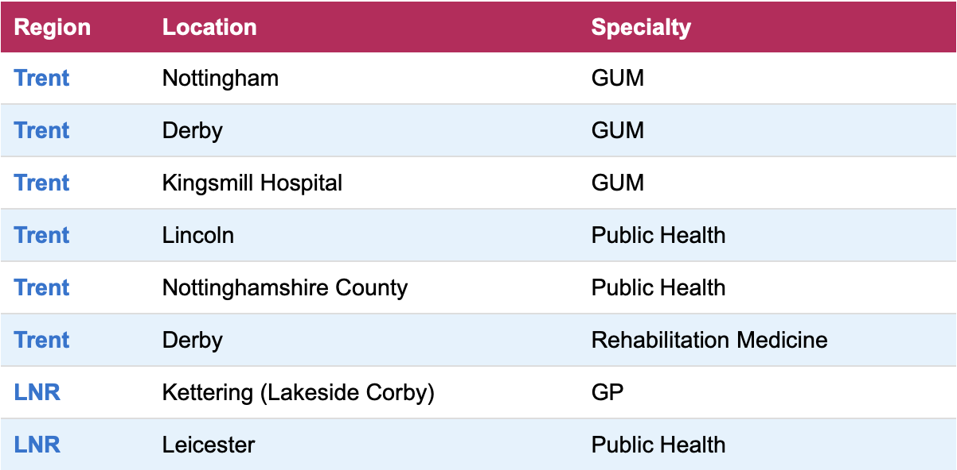

Feedback from previous trainees

“I really , really loved being able to step out of clinical work setting and simply have conversation about sexual health in the community”

“It is integrated with the course and very relatable with enhance learning”

“Learn and explore management of patients from a holistic view”

“Got me to think about how I can provide holistic care and other factors which play a part of patient care”

“Good integration into community clinics which increased exposure to community healthcare”

“I was able to deliver educational workshops to local schools, colleges and people with LD at SPACE inclusive”

“Different to the clinical side of medicine”

Information for Enhance Explore trainees

Enhance Handbook (doc)
Fact sheet (doc)
Enhance checklist (doc)

Information for Clinical Supervisors

Enhance for supervisors (doc)
National Enhance Educator Guide
Certificate of completion of Enhance Explore (doc)

